Infinite Campus: Mathematics Achievement Fund Quick Reference Card
Release date: 4/10/19
Custom Report: Mathematics Achievement Fund – The purpose of this report is to provide data from the Intervention and Assessment tabs in Infinite Campus for students served by the Mathematics Achievement Fund (MAF) grant and indicate a student’s growth or decline in scores.
Selection Criteria: Use the Campus toolbar to select the school/academic year you would like to use for the report. Select “All Schools” to generate a district report.
KDE Contact: Erin Chavez, Office of Standards, Assessment and Accountability
Pathway: KY State Reporting > KDE Reports > Mathematics Achievement Fund
NOTE: Users must be granted access by local KSIS administrator before they will see this report.
Report Sample: The report will generate in Excel format. To generate the report, select Detail Report or Aggregate Report then click the Generate Report button.
The Detail report returns a spreadsheet of student-level data from the Intervention tab and the MAF assessment data from the Assessment tab. Available MAF assessment scores for the fall, winter and spring reporting dates display on the report.
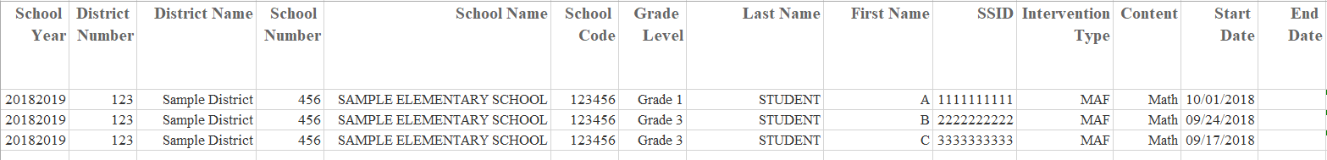
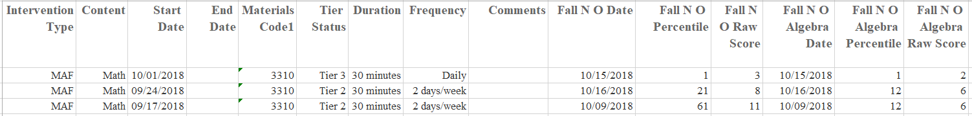
The Aggregate report will provide either All Schools with school counts/averages by grade level or if a single school is selected, all school counts/averages by grade level for that school.
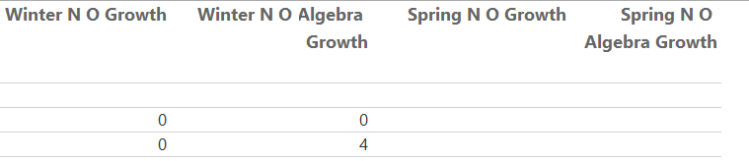
Suggested report uses:
Data from the aggregate and detailed reports should be used by the MAF team to:
- review individual student intervention data along with their assessment scores to determine growth or decline;
- analyze student-level data to make further instructional decisions regarding specific interventions and changes in frequency/duration needed in moving student learning forward; and
- to report progress to parents of students who are receiving intervention services.

